**User Stories**

**User Number 1**

As a mom I like reading boks so much so I registered to Di-Lib system and I can search and find my favorite books and I can read them. This makes me save a lot of time to find a book and save a lot of space in my home because all of this is digital.

***Story priority : Low***

***Pre and Post Conditions :*** It is hard to spend time outside for her so she uses the Di-Lib to access to the books more easily.

**User number 2**

I am a middle age man who likes reading books since childhood. Sometimes my work become so much and I can’t find any time to look new books to read so I registered on Di-Lib and my life is changed. I can find any category on the system and select a book as I like in my home. With that I don’t need to go to a book store to find new books and new genres.

***Story priority : Medium***

***Pre and Post Conditions :*** He is working hard and he can not easily find the book he likes so he uses Di-Lib and he saves his time and he can find the books that he enjoys.

**User number 3**

I am a student who likes to collect different books of a different series. I can call myself a collector. But it can be a difficult thing because sometimes I can’t find the books I want or some books are not being printed anymore. This makes my hobby very unplesant. That is why I joined the Di-Lib. On the system I can find every book a want and I can build my own digital library. I can collect the books I looking for easily. Di-Lib helped me a lot.

***Story priority : Medium***

***Pre and Post Conditions :*** He/she likes collecting books on his/her library but he/she having a hard time to find some of the books he/she wants. So he/she decided to build a digital library on Di-Lib.

**User number 4**

I am a critic of a some newspaper. I am sharing my own comments on my page. But my comments can not be read by majority. Not everyone is reading the newspaper that I write. When I heard I can share my comments on Di-Lib I registered the system so now I can share my comments about the books on my page and with that I can reach much more people than newspapers. This is a whole new level for my job.

***Story priority : High***

***Pre and Post Conditions :*** He is a critic and he can’t reach many people by newspapers so he uses Di-Lib and share his comments to majority.

Kullanıcı veya yönetici, uygulamamızdaki kitaplara ve uygulamamızdaki kişisel kütüphaneye erişmek için oturum açar.

**User number 5**

I am a amator writer. For many years I wrote many books but none of them has been published. Publishers didn’t like my books or they think they couldn’t earn much money. This made me very upset for many years. But some time ago I heard a app that named Di-Lib. I found I can publish my books on the system online and I registered and published my books. People loved them. They posted thousands of good review to my books. With the help of Di-Lib I published my books.

***Story priority : High***

***Pre and Post Conditions :*** As a amator writer, it is hard to share his books with other people so he uses Di-Lib and publishes his books online to find new readers.

***Sprint Plan Table***

|  |  |  |
| --- | --- | --- |
| **1st Sprint (Backlog)** | **2nd Sprint (Daveloping and In-Process)** | **3rd Sprint(Completed)** |
| **User interface will be made more useful** | **Login processes for users and administrators(Atakan)** | **User interface design(Onur)** |
| **Admin interface will be made more useful** | **Admin interface improved(Onur)** | **Adding books to the database(Utku)** |
|  | **Registration of users in database(Utku)** | **Adding user settings(Atakan)** |
|  |  | **System optimization(Utku)** |

***Key Features of the User Interface***

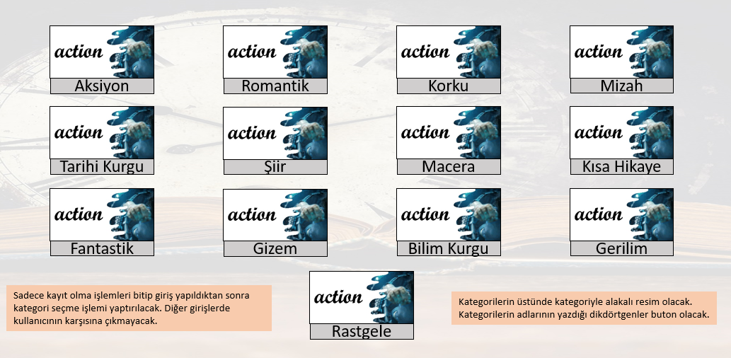***Categories***

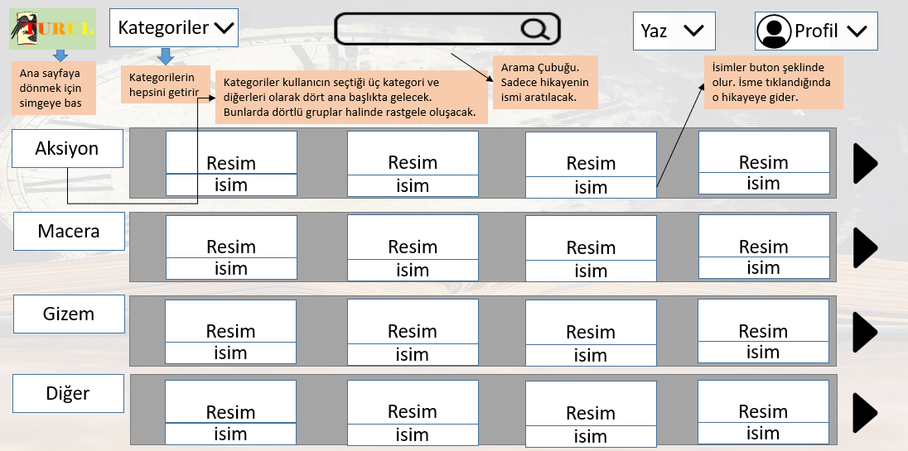***Interface***

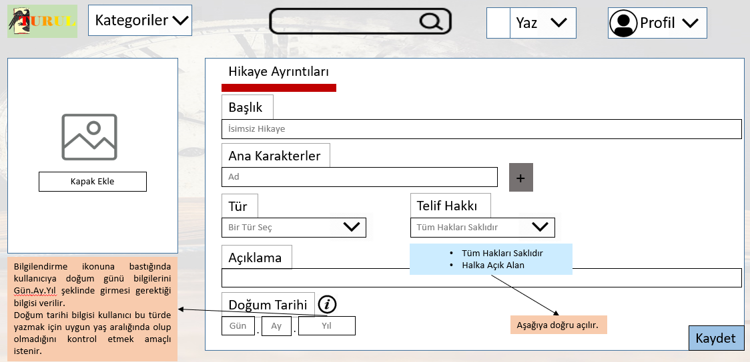***Adding books***

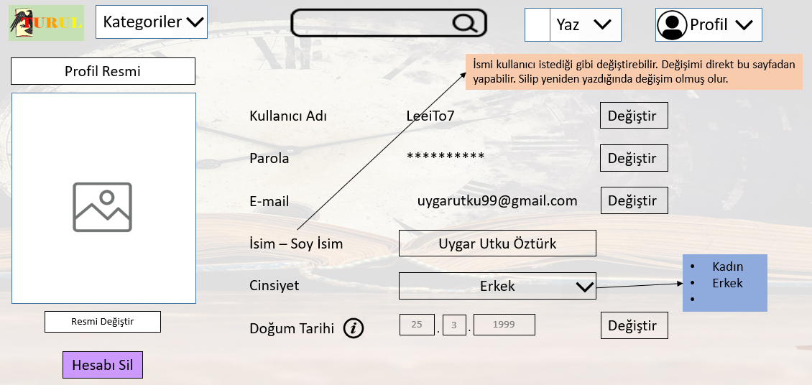***Profile***